Background in Croatia
In 2012, Croatia began developing a strategic plan for palliative care, marking a significant step forward in improving these services. One major goal set in 2014 was to create a comprehensive palliative care system that integrates healthcare and social welfare. This means ensuring that patients receive holistic support that covers both their medical and social needs. The focus on integration aims to make palliative care more accessible and of higher quality throughout Croatia.

The main objective of the initiative was to prioritize patient-centered care, coordination, and continuity, alongside embracing a holistic interdisciplinary approach, all of which are essential elements for effective palliative care. Croatia's healthcare infrastructure and coverage allowed for a smoother integration of various aspects of care, ensuring that patients receive comprehensive support tailored to their needs throughout their palliative care journey.

In 2016, the Croatian programme of integrated palliative care was included into the EU-funded Horizon2020 project SELFIE 2020.

Strategic plan, emphasised a shift in approach to palliative care in Croatia:

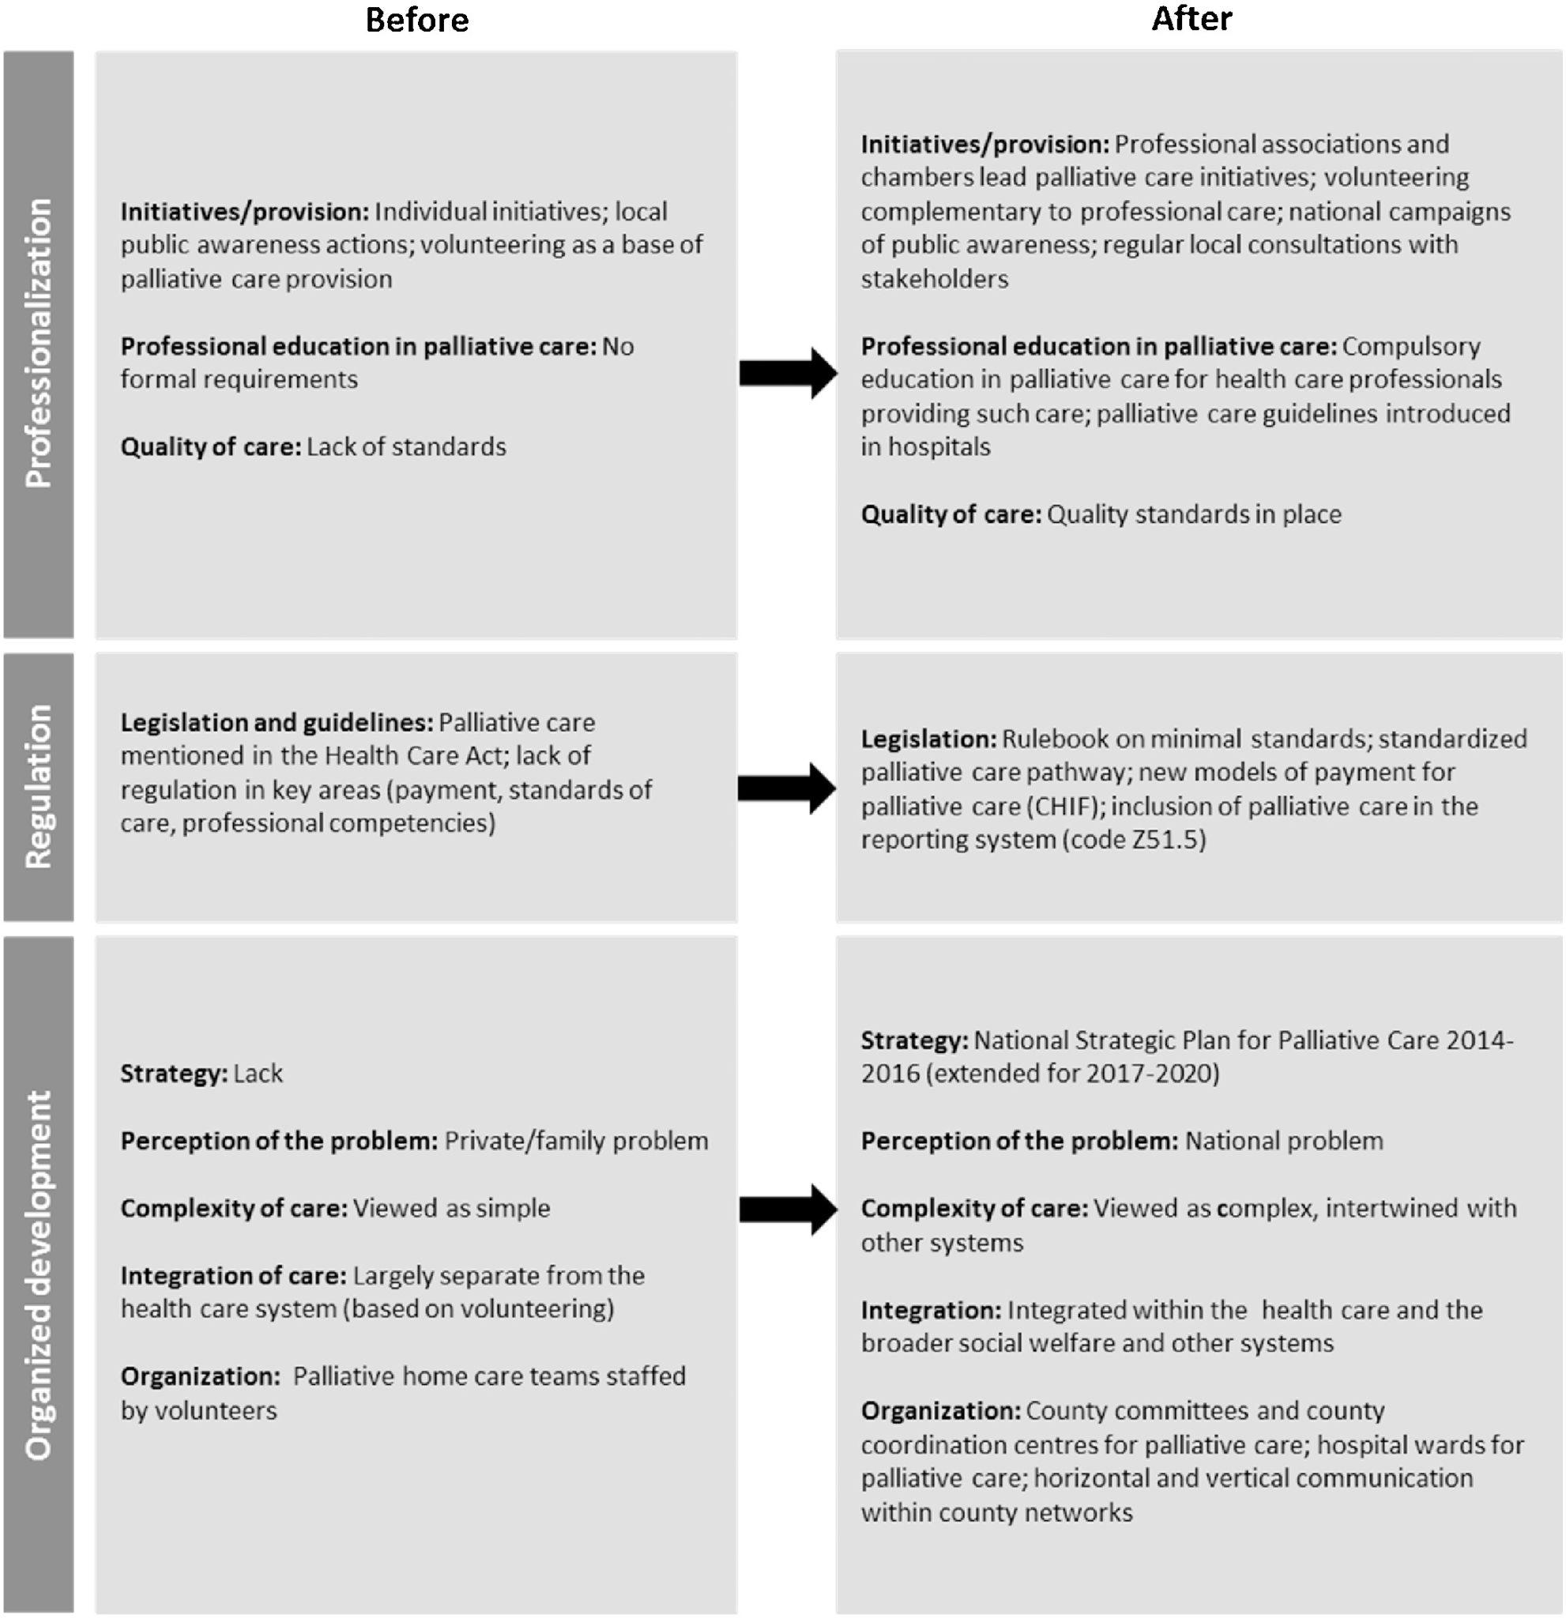
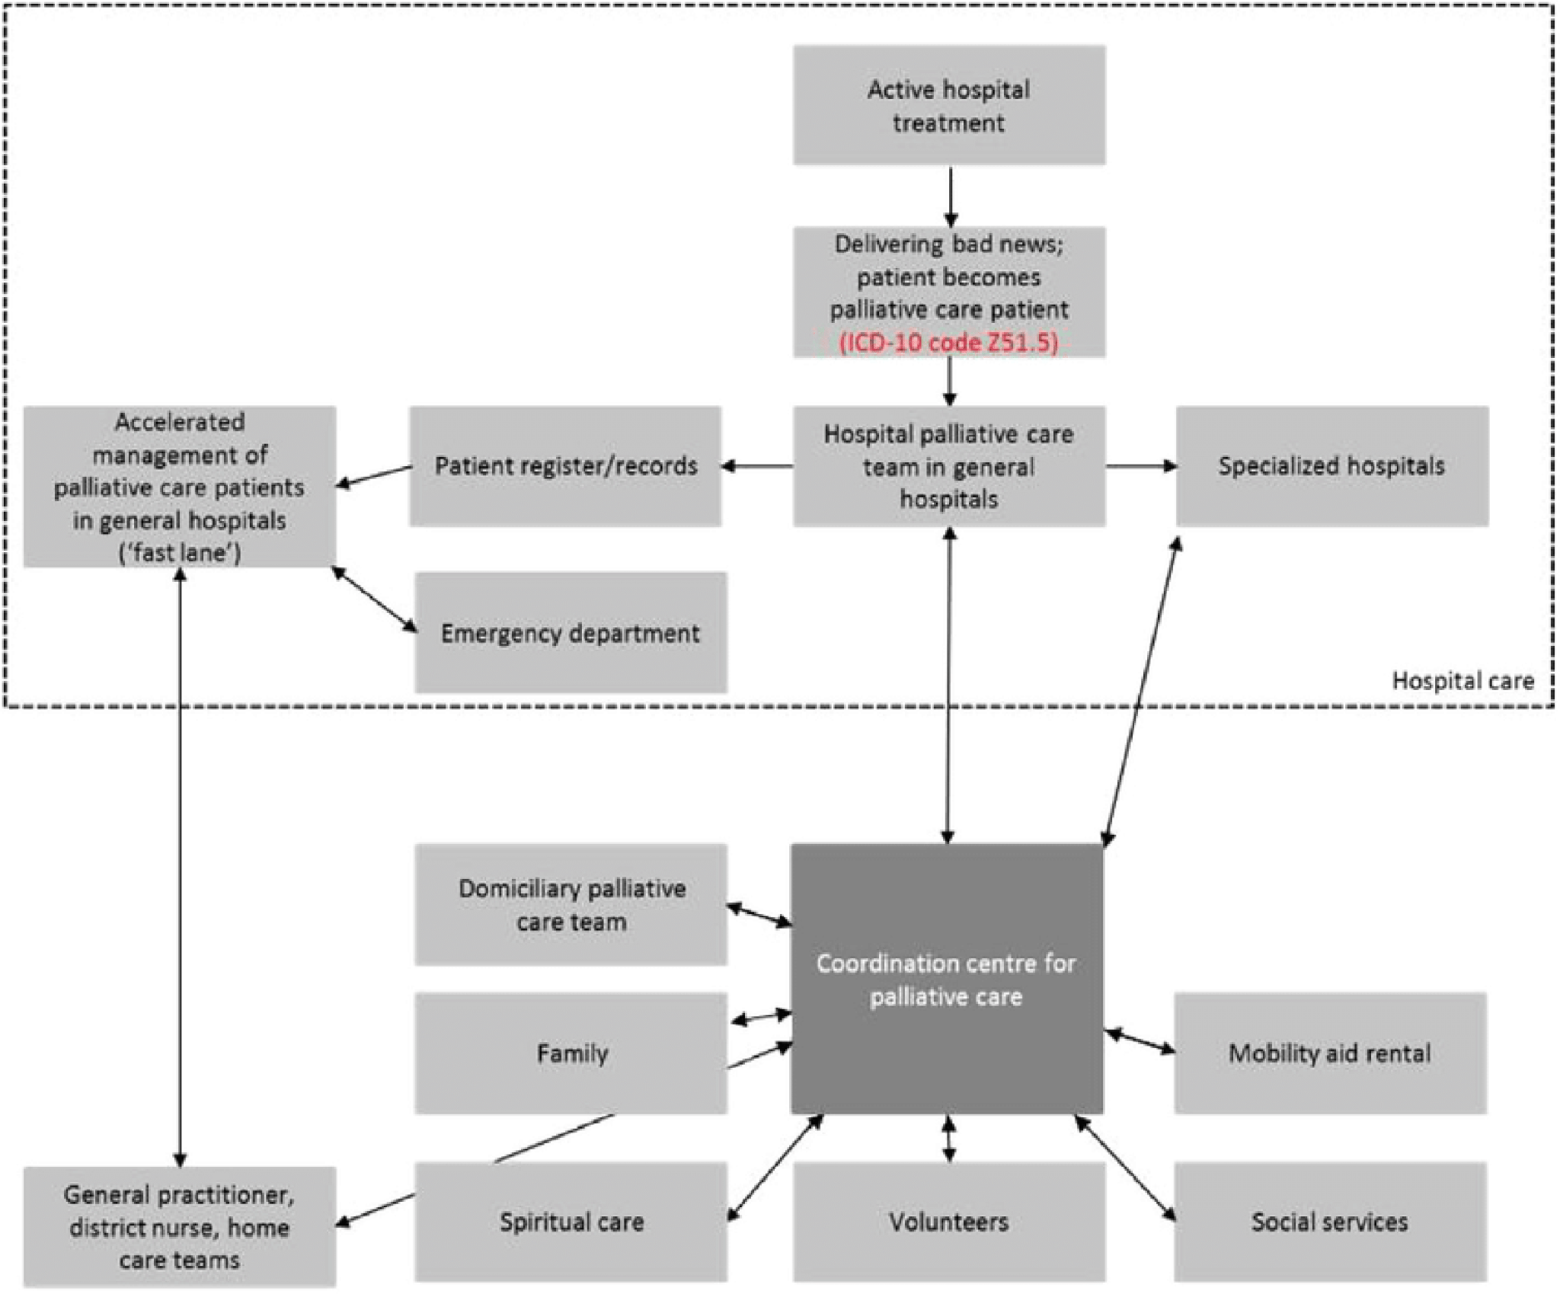
National palliative care pathway in Croatia

Role of Volunteers:
In Croatia, volunteer work in palliative care started in the 1990s. Initially, volunteers focused on visiting patients at home and educating the public and professionals about palliative care. The legal framework for organizing palliative care was established in 2003. However, significant progress occurred only after the adoption of the palliative care strategy in 2014.

The activities carried out by volunteers in palliative care are expected of:
-psychosocial support aims to enable individuals to effectively manage stress, fear, sadness, and other emotions while adapting to changes in their life due to a severe illness or loss.
-Volunteers witness the uncertainty experienced by patients and their families when they receive news about the incurable nature of the illness or the cessation of curative treatment. This uncertainty often stems from a lack of awareness about available resources and rights, as well as a lack of understanding about the forthcoming procedures. Volunteers play a crucial role in alleviating this confusion by offering information, guidance, and advice. Additionally, for certain groups, volunteers actively advocate for the utilisation of their rights through appropriate channels and institutions.
-Formal volunteers gathered by NGOs can support individuals borrow medical and orthopedic aids free of charge. These aids include beds, walkers, crutches, anti-decubitus mattresses, infusion stands, and more. This service is crucial for offering home care support, particularly benefiting individuals from lower socioeconomic backgrounds who may not afford these aids otherwise.
-Focus on assisting individuals with instrumental activities of daily living (IADLs). These activities include tasks like buying groceries and medications, attending medical appointments, and participating in religious activities. Volunteers offer support to help individuals maintain their independence and cope with daily life challenges, especially for those who may have difficulty performing these tasks on their own.
-Supporting the families of patients, especially in pediatric palliative care, is crucial. It's often considered just as important as caring for the patient themselves. When volunteers are matched with families, it's important to ensure that they are accepted and fit well with the family dynamics. This personalized approach highlights how essential family well-being is in pediatric palliative care.
-Raising Awareness of Palliative Care

Quality standards in palliative care by medical professionals:

The Croatian Ministry of Health released guidelines in 2021 aimed at enhancing the quality of palliative care in Intensive Care Units (ICUs). These guidelines emphasize the importance of restricting futile treatments for patients nearing the end of life and ensuring personalized palliative care instead.

Nurses’ Knowledge of Palliative Care: The findings suggest that nurses generally have insufficient knowledge of palliative care, although they exhibit better understanding in the area of pain and symptom management. Interestingly, there appears to be no significant variation in palliative care knowledge based on factors such as gender, age, or work experience. However, nurses who have received informal education demonstrate a higher level of knowledge in palliative care. This signifies the potential effectiveness of informal educational interventions in improving nurses' understanding of palliative care, highlighting the importance of ongoing training and education in this field. https://hrcak.srce.hr/file/335905
Since in Croatia nurses are insufficiently trained in palliative care unlike many other countries around the world, vocational training is suggested.

Bachelor's degree in the field of palliative health care for patients since 2014 nurses are trained for the following competencies, and will be able to:
• explain the philosophy and principles of palliative health care;
• specify the organizational forms and levels of palliative care;
• identify the basic characteristics of palliative care in hospital, hospice and community;
• assess needs, plan, implement and evaluate palliative health care;
• apply procedures for solving and alleviating the patient's symptoms and suffering;
• organize professional and social support for the patient and his family;
• comment on ethical issues in palliative care (Common mandatory part of the undergraduate nursing study program (core curriculum) of the Ministry of Health
2014).

The key aspects related to quality of care in palliative medicine :

1. Structure and Process of Care: The structure and process of palliative care involve a well-organized system where healthcare professionals work together smoothly. This includes making sure everyone involved in the care - doctors, nurses, and others - receives proper education and training. It's important to keep care consistent from start to finish, so patients get the best support possible. Patients should also get all the information they need to make choices about their care, giving them control over their treatment decisions.

2. Physical Aspects: In addressing the physical aspects of care, healthcare providers focus on two main areas: measuring and documenting pain and other symptoms, and evaluating and managing these symptoms and any associated side effects. This involves accurately assessing the intensity and nature of symptoms like pain, nausea, or fatigue, and keeping detailed records of these assessments. Once identified, healthcare professionals work to effectively manage symptoms through various interventions such as medications, therapies, or lifestyle adjustments, while also addressing any potential side effects that may arise from treatment.

3. Psychological and Psychiatric Aspects of Care: focus on measuring, documenting, and managing various emotional challenges that patients and their families may face. This includes assessing and addressing fear, depression, and other psychological symptoms through careful observation and documentation. Additionally, healthcare professionals evaluate and manage family members' psychological reactions, such as grief and bereavement, providing support and resources to help them cope with the emotional impact of their loved one's illness or death.

4. Social Aspects of Care: prioritize continuous support and communication with the patient's family. This includes explaining the reasons behind certain medical procedures and decisions in a clear and compassionate manner. Additionally, healthcare professionals offer ongoing support and comprehensive social care services to the family, recognizing their role as primary caregivers and ensuring their needs are met throughout the patient's journey.

5. Spiritual, Religious, and Existential Aspects: offer information about available spiritual resources and support, respecting the diverse beliefs and practices of patients and families.

6. Cultural Aspects: assessing their cultural views, understanding their ability to accept information, language preferences, and rituals, and integrating these aspects into their care plan.

7. Care of the Dying Patient: Recognize and meticulously document the transition to the immediate debilitating phase of illness. They ensure the patient's and family's wishes regarding the place of death are secured and documented, and implement a grief and bereavement plan accordingly.

8. Ethical and Legal Aspects of Care: Adhering to ethical principles and legal guidelines in decision-making, respecting patient autonomy, and ensuring transparency and accountability in care delivery.

Resources:
NATIONAL PROGRAM FOR THE DEVELOPMENT OF PALLIATIVE CARE IN THE REPUBLIC OF CROATIA 2017 - 2020 : https://wp.medicusnet.hr/wp-content/uploads/2019/01/NP-RAZVOJA-PALIJATIVNE-SKRBI-RH-2017-2020-usvojen-18.10.2017.1.pdf

https://zdravlje.gov.hr/UserDocsImages/dokumenti/Programi,%20projekti%20i%20strategije/Strate%C5%A1ki_plan_razvoja_palijativne_skrbi_u_RH_za_razdoblje_2014-2016..pdf
https://www.eapcnet.eu/Portals/0/adam/Content/LmgAajW9M0Os7VYZs0ZXCQ/Text/White%20Paper%20on%20standards%20and%20norms%20for%20hospice%20and%20palliative%20care%20in%20Europe.pdf
https://doi.org/10.1016/j.healthpol.2022.01.009
https://www.sciencedirect.com/science/article/pii/S0168851018302732?via%3Dihub#bib0005
https://www.sciencedirect.com/science/article/pii/S0168851018302732?via%3Dihub
Kovaˇcevi´c, B. Development of the Istria County Palliative Care Coordination Center, Razvoj Koordinacijskog Centra Palijativne Skrbi Istarske Županije. Master’s Thesis, School of Medicine, University of Zagreb, Zagreb, Croatia, 2016.
https://www.researchgate.net/publication/361836583_A_Qualitative_Study_on_the_Position_and_Role_of_Volunteers_in_Integrated_Care-An_Example_of_Palliative_Care_in_Croatia#pfd
https://zdravlje.gov.hr/programi-i-projekti/nacionalni-programi-projekti-i-strategije/nacionalni-transplantacijski-program/informacije-za-strucnjake/2564
Quality indicators for palliative care.A systematic review. Journal of Pain and Symptom management Vol 38 No 1 :145-156,2009

